UNC3886 Cyber Espionage Campaign Against Singapore’s telecommunications Critical Infrastructure (2025)
- Shrivibhu M S,
BCA 5th Sem ‘A’ Sec (AI&ML)
City College Jayanagar

ABSTRACT
This paper is about the cyber-espionage campaign that targeted Singapore’s telecommunication’s sector and the defensive response that followed. Singapore first disclosed the campaign in July 2025, then CSA and IMDA released further details in February 2026. Mandiant’s 2024 reporting is used only to explain UNC3886’s broader activity against network and virtualization systems, it is not treated as the evidence that the same tools were used in Singapore. The official reports identify M1, SIMBA Telecom, Singtel and StarHub as targets. It confirms unauthorized access, a Zero-Day bypass of a perimeter firewall in one instance, use of rootkit in another, and theft of a small amount of technical, mainly network-related information. Authorities reported that there’s no evidence of customer personal information being accessed or taken, and no evidence of telecom services being disrupted. In response Operation CYBER GUARDIAN gathered more than 100 defenders from government and private industry, and the operation was carried out for more than eleven months. The case shows why infrastructure devices can be difficult to monitor and investigate. It also highlights the value of Zero-Trust when combined with segmentation. Privileged-access controls, threat-hunting, and coordinated incident response. The confirmed impact was limited, but the intrusion still exposed meaningful risks.

INTRODUCTION AND BACKGROUND
- Singapore CII: Singapore’s Cybersecurity Act establishes oversight for systems directly involved in essential services and describes Critical Information Infrastructure (CII) obligations. Telecommunications operations depend on connected systems spanning external gateways, management places, identity services, data centers, virtualization and operational networks. A security event can severely impact confidentiality, integrity or availability.
- Telecommunications as critical infrastructure: Service providers carry communications and interconnect with other operators and services. Their network maps, configurations, routing relationships and management paths can have great value even without customer content. Concentrated dependencies also mean that disruption could have consequences beyond a single provider. This is sector-level observations, not claiming that those consequences occurred in this incident.
- APTs and espionage: Espionage operations seek information and a very long access period. A quiet intrusion may prioritize learning network topology and administration work-flows rather then immediate damage. “Persistent” describes a strategic objective, not proof that access lasted a particular duration. The publicly stated 11+ months refers to the coordinated response operation carried out, not the amount of time attackers-maintained access.
- UNC3886: MITRE tracks UNC3886 as a China-nexus espionage group targeting defense, technology and telecommunications organizations, with a demonstrated understanding of edge devise and virtualization. Mandiant’s 2024 research described past UNC3886 exploitation of Fortinet and VMware vulnerabilities, credential collection, rootkits on virtual machines and persistence across network devices, hypervisors and guests. A separate 2024 report documented exploitation of CVE2023-34048 in vCenter since late 2021. In 2025 Mandiant reported juniper router backdoors discovered in mid-2024, including log interference and use of legitimate credentials. These reports establish a broader pattern of targeting infrastructure.
- Singapore’s environment: The CSA/IMDA operation involved sector regulators, national cyber defenders and all four major providers, this collaborative approach is relevant because no single operator can observe every cross-sector dependency.
- Timeline context: In 2024, Mandiant published research about broader UNC3886 activity, including earlier operations and juniper activity observed in mid-2024. Singapore’s campaign was publicly disclosed on 18 July 2025. Detailed Singapore-specific findings were released on 9 February 2026.

INCIDENT DESCRIPTION
What happened?
In 2025, Singapore’s telecommunications sector was targeted by UNC3886, an APT actor. The campaign was deliberate, targeted and well planned, and affected all four of Singapore’s major telecommunications operators: M1, SIMBA Telecom, Singtel and StarHub. The attackers used advanced techniques to get unauthorized access to telecommunications networks and maintain it. In one confirmed case, UNC3886 used Zero-day exploit to bypass a perimeter firewall and get access to a telecommunication network. A small amount of technical data, mainly related to network was exfiltrated. In another case the attackers used rootkits and other advanced tools to maintain persistence, hide their activity and escape detection.
The publicly available information does not specify which telecommunication experienced which technique, the exact vulnerability exploited or the precise amount of data that was exfiltrated. Importantly, the investigation found no evidence that customer information or other personal data was exfiltrated. And there was no evidence that the attackers disrupted the telecommunications or internet services.

How it happened and how it was detected?
The exact initial compromise and detection dates have not been publicly disclosed. Singapore first publicly acknowledged the incident on 18 July 2025, when the coordinating Minister for National Security stated that UNC3886 had been detected attacking their critical infrastructure. Further details were withheld at that time for security reasons.
The later investigation established that the affected telecommunications operators themselves initially detected the malicious activity and reported it to Cyber Security Agency of Singapore (CSA) and the Infocomm Media Development Authority (IMDA). This triggered a coordinated public-private response. The response was named CYBER GUARDIAN. It involved more than 100 cyber defenders’ multiple government agencies and affected operators. It was carried out for more than 11 months. The response included containment, threat-hunting, forensic investigation, closing the attacker’s access pints and strengthening monitoring.

Timeline of events
Before July 2025: UNC3886 conducted targeted APT against Singapore’s critical infrastructure. The exact initial compromise date and attack sequence have not been publicly disclosed.
18 July 2025: Singapore disclosed that UNC3886 had been detected attacking their critical infrastructure. Further details were withheld for security reasons.
19 July 2025: CSA confirmed that it was leading investigators into UNC3886 activity working with affected organizations and partners.
After detection: The affected telecommunications operators notified CSA and IMDA. Govt agencies and telecoms began coordinated investigation and containment effort.
Following detection: Operation CYBER GUARDIAN was conducted. More than 100 defenders worked for more than 11 months to investigate intrusion, hunt for threats, contain attackers and protect telecoms network.
During the investigation: Authorities established that all four major telecoms had been targeted. They also confirmed a Zero-day firewall bypass in one case and use of rootkit to hide in another, and limited technical data exfiltration.
9 February 2026: CSA and IMDA publicly released detailed information about the campaign and Operation CYBER GUARDIAN.
By February 2026: The response had contained the campaign, closed identifies access points and expanded monitoring capabilities. There was no evidence of customer data theft or telecoms service disruption.

ATTACK TYPE AND VULNERABILITY EXPLOITATION
Attack Type:
The UNC3886 is classified as an Advanced Persistent Threat (APT) cyber-espionage campaign. An APT is a sophisticated and persistent form of cyber attack in which an attacker uses advanced techniques to get unauthorized access to a high-value target and attempts to remain inside the environment for a very long time while avoiding detection. In the Singapore incident, UNC3886 conducted a deliberate and targeted campaign against the country’s four major telecommunications operators: M1, SIMBA telecoms, Singtel, StarHub. The attackers used advanced tools to get access to telecom systems, maintain access and evade detection. The campaign was rather different from short-termed attacks such as malware, ransomware or phishing, it was a persistent carefully planned operation focused on cyber-espionage.
Vulnerability Exploitation:
- Zero-Day Exploitation
The most significant confirmed vulnerability was a Zero-day vulnerability.
In one case, UNC3886 used a zero-day exploit to bypass the perimeter firewall of a telecoms operator and gained access to the telecom’s internal network. A Zero-day is a previously unknown vulnerability for which a security patch is not yet available when it is exploited.
The Singapore authorities did not disclose the affected firewall product, vulnerability identifier, CVE number, or the exact exploit chain.

How it worked, based on confirmed information:
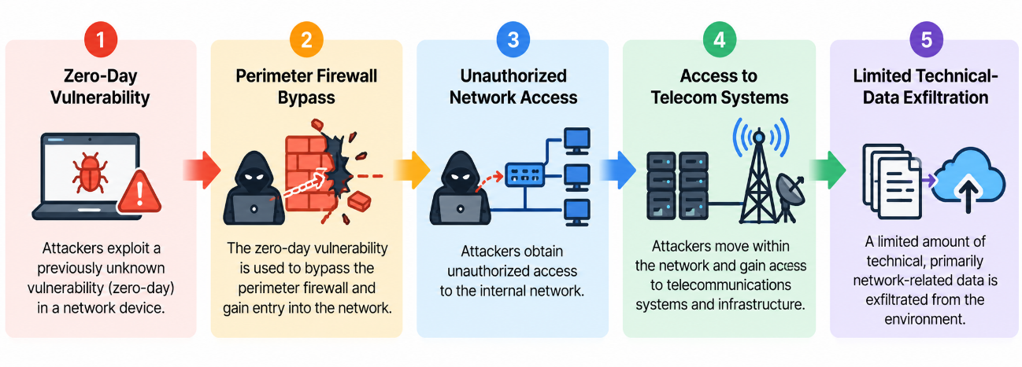
The important security implication is that the firewall, which normally acts as a major network boundary, was bypassed. This allowed the attackers to enter the protected network without relying on a conventional phishing or malware delivery route.

- Rootkit-Based Stealth and Persistence
In another case, UNC3886 used rootkits and other advanced tools.
A rootkit is a malicious software designed to hide its presence and maintain privileged, persistent access to a compromised system. In this campaign, the authorities reported that the attackers used rootkits to maintain persistent access, cover their tracks and evade detection.
This made detection particularly difficult because the attackers were not simply trying to obtain access and leave. They attempted to remain inside the environment while hiding their activities.

The general attack pattern can be represented as:
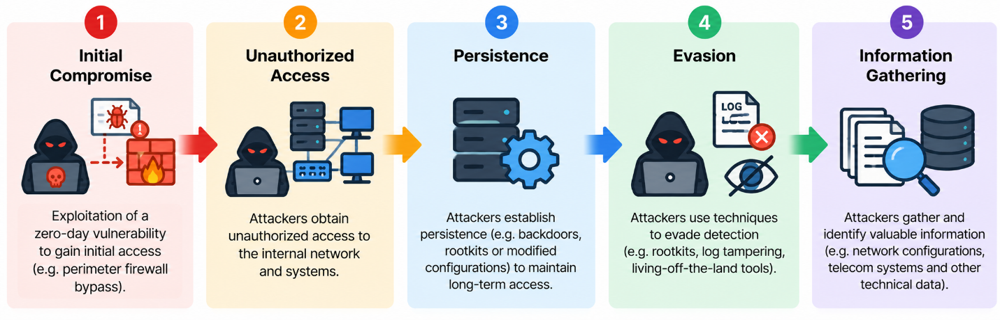
The exact rootkit, affected system and technical implementation were not publicly disclosed.

- Cyber-Espionage and Data Exfiltration
The overall objective is best described as cyber-espionage rather than service disruption or financial extortion.
In the confirmed Zero-day case, the attackers exfiltrated a small amount of technical data, mainly related to network information. The authorities stated that there was no evidence of customer or other sensitive information being accessed or exfiltrated. There was also no evidence that telecom services were disrupted.
This indicates that the attackers’ activity focused on obtaining information about the telecoms environment rather than immediately causing an outrage.

ROOT CAUSE ANALYSIS
The publicly available information does not identify a single specific security failure as the root cause of the UNC3886 campaign. However, the incident demonstrates weakness associated with telecommunications infrastructure and network boundary security. In one confirmed case, a Zero-day vulnerability allowed the attackers to bypass a perimeter firewall and gain access to the telecom network, showing that dependence on a perimeter device as the main security boundary can create a significant risk when that device is compromised.
The use of the rootkits in another case also shows the difficulty of detecting the threats operating withing infrastructure. In addition, limited visibility into network and management infrastructure can allow attackers to maintain access without being detected.
Therefore, the main underlying security gap can be described as insufficiently layered protection and monitoring of critical network infrastructure, rather than a single configuration error or employee mistake.

IMPACT ANALYSIS
- Technical impact: According to detailed official disclosure, unauthorized access is confirmed leading to limited access to critical systems obtaining in at least one case. Use of rootkits indicates that defenders faced a compromised trust in local system evidence. The public record does not identify the exact information or the extent of access across the operators.
- Data impact: A small amount of technical, mainly network related information was confirmed to be exfiltrated. The authorities reported that no evidence of customer information or sensitive personal information being accessed or exfiltrated. However, this does not prove that other information was not accessed.
- Operational impact: CSA/IMDA reported there was no evidence of telecommunications services being disrupted. No service outage was implied. The response required prolonged coordinated defense effort, which is a real operational cost.
- Security and national-security impact: Gaining access to communications network allows attackers to wait and disable critical services later. Potential impact is not actual impact. A network map may aid for targeting later, in theory compromised control planes could affect traffic or availability. These are just analytical possibilities, not the impact observed in this case.
- Financial and reputation impact: the authoritative public source reviewed for this study quantifies no financial loss or customer avoiding the service from the affected operators. Reputational effects are plausible after the disclosure, but no measured impact is reported.

DETECTION AND RESPONSE
The UNC3886 activity was initially detected by the affected telecommunications operators, who notified the IMDA/CSA. The detection was particularly challenging as the group used advanced techniques and tools such as rootkit to hide and cover their tracks and maintain the access to the network and escape the detection. As a result, cyber defenders had to conduct a thorough and complete security check across the affected networks rather than relying on a single security alert. The exact detection date and specific tool used to identify the unauthorized access have not been publicly disclosed.
Following the notification, CSA, IMDA and other government and private agencies alike worked together with the affected telecommunications operators to contain the breach. This coordinated response team/operation was named CYBER GUARDIAN, Singapore’s largest coordinated cyber incident response team ever which contained more than 100 members. These cyber defenders from multiple government agencies and private sectors along with affected telecommunications operators participated in the operation for more than 11 months. The response included investigating the affected networks, conducting threat-hunting and forensic analysis, limiting the attacker’s movement and collecting evidence to understand the extent of the compromise.
The response team also implemented measures to close the access points used by UNC3886 and strengthen monitoring capabilities within the targeted telecommunications networks. Additional defense activities include joint threat-hunting, penetration testing and improving the detection capabilities. These measures were not only intended to remove the immediate threat but also to prevent UNC3886 from regaining access to the networks.
The coordinated response successfully contained the campaign before it could result in major operation damage and service disruption. Although the attackers gained unauthorized access to parts of the telecommunications networks and in, one case, obtained limited access to critical systems, they did not progress far enough to disrupt telecommunications services. Authorities also reported no evidence of customer information or other sensitive information being accessed or exfiltrated. The incident therefore demonstrated the importance of rapid detection, information sharing, coordinated threat-hunting and collaboration between government agencies and critical infrastructure operators.

SECURITY MEASURES AND MITIGATION
Following the detection of the UNC3886 campaign, the affected telecommunications operators worked with CSA and IMDA to investigate the compromised environments and strengthen their security. The response involved thorough and complete security check, threat-hunting, forensic investigation and penetration testing to identify possible traves of the attackers and weaknesses withing the affected infrastructure. More than 100 cyber defenders participated in operation CYBER GUARDIAN for more than 11 months.
The organizations also expanded their monitoring capabilities to improve visibility into suspicious activity across their telecommunications networks. Joint investigations between government agencies and the telecoms helped identify the extent of the compromise and assess whether the attackers had maintained access. These measures were particularly important because UNC3886 had used advanced tools and rootkits that could hide their malicious activity and make detection more difficult.
A key mitigation step was to close the access points used by UNC3886, preventing the attackers from continuing to use the identified routes into the affected networks. The response also focused on limiting the attackers’ movement within the environment and containing the compromise before it could progress further. These actions helped ensure that the attackers could not advance to the point of disrupting telecommunications services.
The affected networks were subjected to continued investigation and monitoring after containment, where rootkits or other forms of persistent compromise are suspected, general incident-response practice would include verifying system integrity, investigating persistence mechanisms and rebuilding affected systems where their integrity cannot be trusted. However, the publicly available information does not specify which particular system-rebuilding or forensic techniques were used by each telecommunications operator. The documented outcome was that the attackers’ access points were closed and monitoring and security measures were strengthened.

LESSONS LEARNED
- The UNC3886 incident demonstrated that perimeter security alone is not enough to protect critical telecommunications infrastructure.
- A Zero-day vulnerability can bypass an important security boundary, while rootkits and other advanced tools can allow attackers to remain hidden.
- Continuous monitoring, threat-hunting and visibility across network and infrastructure systems are therefore very much import for detecting attacks.
- This incident highlighted the importance of coordinated incident response and information sharing.
- Cooperation between telecommunications operators, CSA and IMDA enabled a large-scale investigation and containment effort through operation CYBER GUARDIAN.
- Finally, the case showed that an attack does not need to cause a service disruption or steal customer data to be significant, unauthorized access and limited technical-data exfiltration can still create serious security and information risks.

RECOMMENDATIONS/BEST PRACTICES
Based on the weaknesses demonstrated by the UNC3886 incident, the following measures could help telecommunications and other critical infrastructure organizations to reduce the possibility and impact of similar attacks.
- Implement Zero Trust Architecture
Organizations should adopt Zero Trust principles so that users, devices and systems are not automatically trusted simply because they are inside the internal network. Access to critical resources should require authentication, authorization and appropriate verification, with only the minimum required privileges granted. This can reduce the potential for attackers to move laterally after bypassing a perimeter security control.

- Strengthen Protection of Network Infrastructure
Firewalls, routers, gateways, management systems and other critical infrastructure devices should undergo regular vulnerability assessments, security updates, configuration reviews and security testing. These systems should be treated as important attack surfaces rather than just relying on them only as trusted security boundaries.
- Apply Least-Privilege Access Control
Administrative access to critical systems should be restricted to authorized users only and limited to the permissions required for their roles. Privileges accounts should use strong authentication, access reviews and controlled administrative sessions.
- Improve Continuous Monitoring and Logging
Security monitoring should cover network devices, servers, management systems and other critical infrastructure. Logs should be centrally collected and protected from unauthorized changes so that suspicious activity and unusual network behavior can be identified.
- Strengthen Network Segmentation
Critical systems, management networks and ordinary user environments should be appropriately separated. Access between these segments should be restricted so that compromise of one system does not affect other systems and automatically provide access to other critical resources.
- Improve Zero-Day Preparedness
Organizations should prepare for vulnerabilities for which patches or security may not yet exist. Vulnerability management should be supported by threat intelligence, behavioral monitoring, compensating controls and rapid containment procedures.
- Strengthen Incident Response and Recovery
Organizations should maintain documented procedures for detection, containment, forensic intelligence, eradication and recovery. Regular incident-response exercises can help security teams respond effectively to attacks.
- Conduct Regular Security Testing Threat hunt
Penetration testing, vulnerability assessments, configuration reviews and proactive threat-hunting should be conducted regularly. These practices can help identify weakness and attacker activity before significant damage happens.
- Strengthen Threat Intelligence and Information Sharing
Telecommunications operators and other critical-infrastructure organizations should maintain mechanisms for sharing indicators of compromise, emerging vulnerabilities and threat intelligence with relevant cybersecurity authorities and trusted industry partners. This can help identify coordinated campaigns affecting multiple organizations.

CONCLUSION
The Singapore telecommunications case shows that cyber-espionage can target the infrastructure that requires network trust. CSA/IMDA reported unauthorized access, a Zero-day vulnerability bypass of a perimeter firewall in one case, use for rootkits to hide and cover their tracks in another case and exfiltration of a small amount of network related information. Authorities reported no evidence of customer or sensitive information being accessed or exfiltrated and no evidence of services being disrupted.
Singapore’s Operation CYBER GUARDIAN brought together over 100 cyber defenders from both government and private sectors working with affected telecoms operators for more than 11 months. The operation contained threat-hunting, closing access points used by the attackers and strengthen the monitoring and security measures of the nation. Mandiant’s 2024 research helps explain why network and virtualizations deserve more attention.
The principal defense lesson is layered adaptability. Zero-Trust can reduce complete trust and constraint privilege, segmentation, MFA and device verification can limit lateral movement, monitoring and threat-hunting can identify unusual activity and tested incident response supports safe containment and recovery. But no single architecture completely eliminates the threat of zero-day risk. A combination of controls and sustained public-private cooperation offers most defensible response to UNC3886 type of threat.

REFERENCES
[1] Cyber Security Agency of Singapore (CSA) and Infocomm Media Development Authority (IMDA), “Largest Multi-Agency Cyber Operation Mounted to Counter Threat Posed by Advanced Persistent Threat (APT) Actor UNC3886 to Singapore’s Telecommunications Sector” Feb.9, 2026.
[2] Cyber Security Agency of Singapore (CSA), “Media Statement on our Responses to APTs” Jul.19, 2025.
[3] S. Rose, O. Borchert, S. Mitchell, and S. Connelly, Zero Trust Architecture, NIST Special Publication 800-207 National Institute of Standards and Technology, Gaithersburg, MD, AUG.2020. doi: 10.6028/NIST.SP.800-207.
[4] C. Pascoe, S. Quinn, and K. Scarfone, the NIST Cybersecurity Framework (CSF) 2.0, NIST Cybersecurity White Paper 29, National Institute of Standards and Technology, Feb.2024. doi: 10.6028/NIST.CSWP.29.
[5] K. Rigopoulos, S. Quinn, C. Pascoe, J. Marron, A. Mahn and D. Topper, NIST Cybersecurity Framework 2.0: Resource & Overview Guide, NIST Special Publication 1299, National Institute of Standards and Technology, Feb. 2024. Doi: 10.6028/NIST.SP.1299.
[6] International Organization for Standardization, ISO/IEC 27001:2022 – Information Security, Cybersecurity and Privacy Protection – Information Security Management Systems – Requirements, 3rd ec., Oct.2022.
[7] MITRE, “UNC3886,” MITRE ATT&CK, Group G1048.
[8] Google Cloud / Mandiant, “UNC3866,” Mandiant Threat Intelligence.

